# Implementing Discrete LOD Adjustment using Vertex Removal

## Introduction

Reducing the level of detail (LOD) of a graphical model involves reducing its complexity by removing vertices and edges such that the visual integrity of the model still remains. In practice, as a 3D model moves away from a viewer, its level of detail can be reduced without a perceived change in quality. As the object approaches the viewer, it must then have its level of detail increased. Level of detail techniques increase the efficiency of rendering by decreasing the workload.

Discrete LOD is the concept of producing various models to represent the same object. Based on a number of criteria such as the distance from the viewer or speed of the object, one of the models is chosen to be rendered.

For my project, I have written an application using C++ and the OpenMesh [1] library that, given a triangulated mesh, can decrease and increase the LOD in an iteratively by removing a percentage of vertices that will maintain the best visual representation of the model, storing the reduction in a forest-like data structure and then restore the LOD by traversing this data structure.

This project is quite a bit different than my project proposal. My proposal mentioned a LOD selection method as well as this LOD adjustment but I have elected to only implement the LOD adjustment for lack of time. Furthermore, my paper is not organized exactly as requested but it is ordered logically and all of the information asked for is there.

## LOD Reduction

### Approach:

The approach taken for LOD reduction was that of greedy vertex removal. A predefined number percentage of vertices having the least error due to removal were chosen to be removed. The vertex and all of its adjacent edges are removed, creating a hole. This hole is patched by applying an arbitrary triangulation. For each vertex removed, two triangle faces are removed as well.

Error measure:

The error measure chosen was the change in volume introduced by removing vertex. The algorithm for calculating this error is shown in steps below. The error data structure consists of the calculated volume called the error, the vertex handle that the error belongs to, and a list of adjacent vertices used for retriangulating the hole that is created once the vertex is removed.

1. For each vertex in mesh:
2. Find barycenter of adjacent vertices (black vertices in image below)
3. For each adjacent face (to blue vertex in image below) sum:
4. Calculate volume using 3 points of face and barycenter point
5. This sum is considered the error of that vertex
6. Take a predefined number of vertices with the minimum error

**Algorithm 1.** Calculation of Error

struct Error {

double error;

MyMesh::VertexHandle vertex;

vector <MyMesh::VertexHandle> adjacent_verts;

};

**Figure 1.** Error data structure

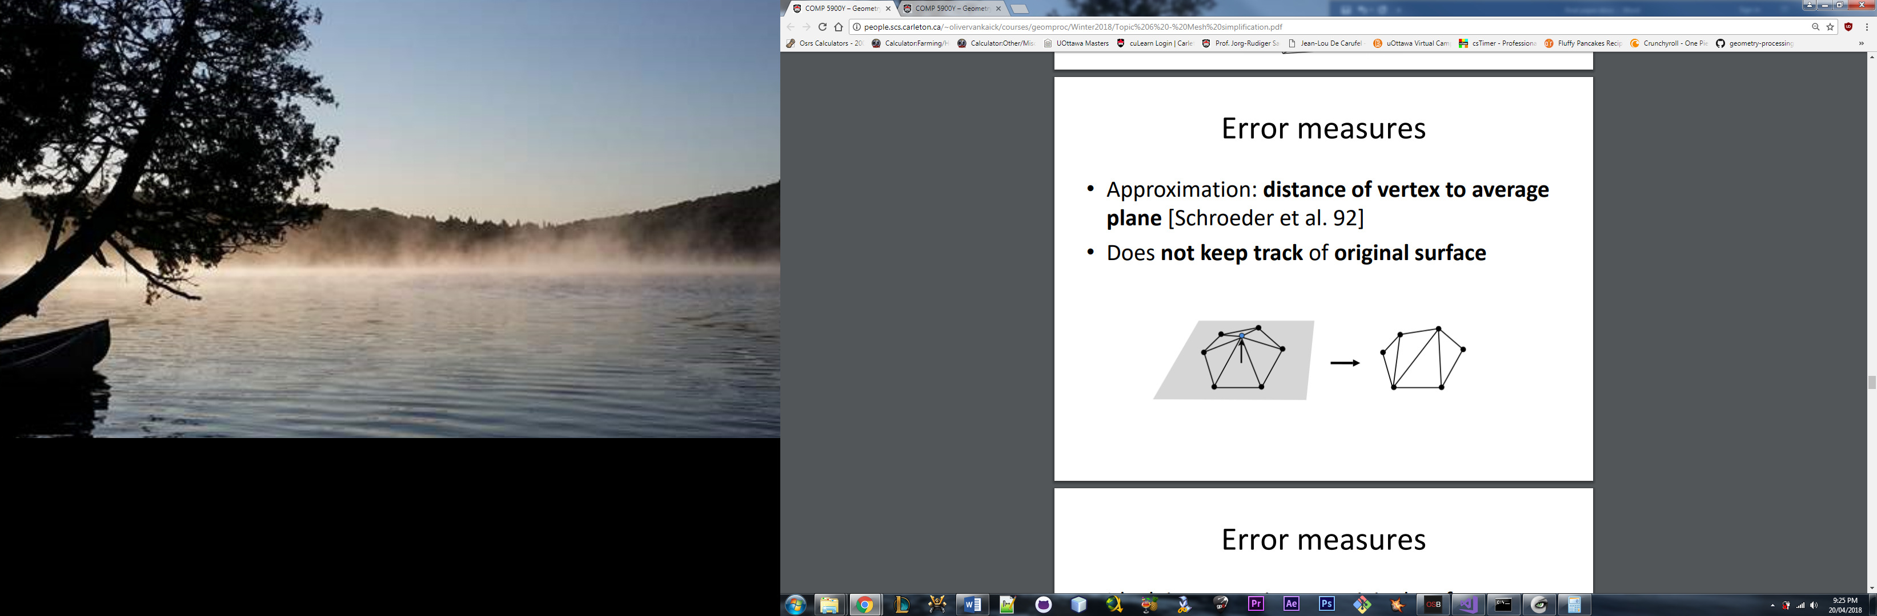

**Figure 2.** Removal of vertex [2]

## Implementation

More specifically, LOD was reduced iteratively. That is, a predefined percentage of vertices to be removed was defined. For each iteration, the percentage of vertices having the minimum error were identified and removed. Identifying the minimum vertices is of order n time since all vertices in the mesh need to be traversed. A triangulated mesh can be considered a planar graph and planar graph vertices have, on average, degree 6. For each vertex, the error is calculated by first calculating the barycenter of the, on average, 6 adjacent vertices, which takes constant time. Then, on average, 6 volumes are calculated, also taking constant time. The vertices having minimum error are updated as the vertices in the mesh are traversed leading to a total time complexity of O(n) to calculate the minimum errors. Storing the errors in the data structure shown in Figure 1 takes O(n) storage since the number of vertices to remove is defined as a percentage of the number of vertices in the mesh.

To remove the O(n) minimum error vertices, each of the, on average, 6 adjacent edges must be removed, as well as the vertex itself, taking constant time. Next, the hole created must be triangulated. The triangulate() function in OpenMesh does not seem to work so I had to do this manually. At first, I took a naïve approach and chose a vertex to be a source and connected all other adjacent vertices to that one. Unfortunately, this would only work if all holes were convex but it turns out this is not the case as shown in Figure 3. When you define a face and add it to a mesh using OpenMesh, you can check whether the new face is valid or not. That is, if the vertices are ordered in a counter-clockwise fashion and it does not coincide with another face. Therefore, my retriangulation method is a simple nested loop that tries every combination of 3 vertices in the set of adjacent vertices and takes the valid ones. Note that OpenMesh will not let you define duplicate faces so trying every combination is correct. This is not a pretty solution but it yields constant time since, again, there are 6 vertices in the set on average. Also note that you cannot add edges to a mesh in OpenMesh, you must only add vertices and define faces using those vertices.



**Figure 3.** Retriangulation difficulty: adjacent points not always a convex set

Finally, a tree is created for each of the removed vertices and stored in the LOD Restoration data structure defined in the next section. The OpenMesh garbage_collection() function is called after this loop in order to remove the deleted geometry elements from memory as they were previously only marked as “deleted”.

## LOD Restoration

### Data structure:

The data structure I have chosen for restoring LOD is a vector of forests of shallow trees. Each level corresponds to a previous decrease in LOD. For example, if LOD has been decreased by 5% 5 times, there will be 5 levels. Each level stores a vector of trees that consist of the vertex handle of the removed vertex, called the root, along with the triangulation that replaced the removed vertex is stored as a vector of faces so that it can be removed from the mesh before restoring the deleted vertex. The root of each tree is a Node struct which stores the adjacent vertices, also Node structs with an empty list of children, that will be used to connect the removed vertex once it is re-added to the mesh.

The storage complexity of this data structure is O(n) with respect to removed vertices because each is stored once and since a triangulated mesh can be thought of as a planar graph, on average, each vertex has degree 6 which means 6 adjacent vertices and 6 adjacent faces are stored.

I do not know if this is the optimal storage strategy for discrete LOD but it seems clean enough and yields reasonable performance.

struct Node {

MyMesh::VertexHandle vertex;

vector <Node> children;

};

// Shallow tree consisting of a root and a set of children that are leaves

struct LODTree {

Node root;

vector <MyMesh::FaceHandle> temp_triangulation;

};

// Each level contains a shallow tree containing removed vertices and their adjacent vertices (children)

struct LODForest {

vector <vector <LODTree>> levels;

int cur_level = -1; // Incremented every time reduce_LOD is called

};

**Figure 4.** LODForest Data Structure

### Implementation:

To restore the LOD by one step, a level of the LODForest struct is traversed. This takes O(n) time because LOD is reduced by a percentage of the total number of vertices, therefore, this percentage of vertices is to be restored.

First, the temporary triangulation that replaced the deleted vertex must be removed from the mesh. On average, 6 faced are removed from the mesh. I do not know the underlying method OpenMesh uses to perform a deletion of a face but faces are indexed by an integer so, in the worst case, a face can be identified and marked as “deleted” in the time it takes for a binary search which is O(logn). Since this is only done on average 6 times, removing the temporary triangulation takes constant time.

Next, the garbage_collection() function is called. I believe this operation should take linear time with respect to the number of geometry elements marked as deleted which, in this case, is just a constant.

Now, the LOD is restored. For every LODTree in the current level of the LODForest, a deleted vertex is added to the mesh, then connected to its previous adjacent vertices. There are an order of n LODTrees in a level of the LODForest and for each one, creating an edge from its root vertex to the, on average, 6 adjacent vertices takes constant time. Thus, restoring the LOD takes O(n) time.

Finally, the integer representing the current level of the LODForest is decremented.

### Problem:

To delete a geometry element in OpenMesh, it must first be marked as “deleted”, then a call to garbage_collection() must be made. This garbage_collection() function invalidates all stored handles unless they are passed to the function.

In order to reduce the LOD, a predefined number of vertices having minimum calculated error and their adjacent edges (and faces) are removed from the mesh. This yields two options.

The first is that garbage_collection() could be called once all vertices and their adjacent geometry elements have been marked as “deleted”. This option works well for reducing the level of detail because garbage_collection() is very slow and it is not ideal for application performance to have it called many times. Unfortunately, to restore LOD, it is required that the hole created be retriangulated and this temporary triangulation be stored as a set of face handles corresponding to the removed vertex. Calling garbage_collection() invalidates these handles and makes it impossible to determine what has changed in the mesh. To keep handles after calling the function, they need to be passed in a vector of a required type. However, it is not trivial to keep these handles organized if they are to be put in a giant list. It would suffice to somehow keep track of which indices correspond to which vertices and then update the handles in the data structure but this is not clean. OpenMesh should provide a cleaner way to deal with this. Consequently, I have found a number of complaints in online forums related to this issue.

The second option is to call garbage_collection() after each vertex is deleted. This approach, unfortunately, would only work if, for each iteration, only a single vertex is chosen to be deleted. This would add a multiple of n to the time complexity of the algorithm which is certainly not ideal. The reason many vertices cannot be deleted in a pass is that, if two of the minimum error vertices are adjacent, adjacent geometry elements of one of the vertices will be deleted already from the mesh rendering an error at runtime when attempting to retriangulate a hole. This is because minimum vertices are all found first, then removed after.

I did not implement the proposed solution in the first mentioned approach to the problem, therefore, my LOD restoration function does not work, however, if the call to garbage_collection() did not invalidate all face handles, my implementation would work as all of the code is written and tested piecewise.

## Documentation

The main two components of the code are the LOD reduction and LOD restoration as described in previous sections. The source code is contained in the LOD.cpp file provided in the zip folder. The only external library is OpenMesh. The reduction steps are currently hardcoded as 6 steps for a 79% reduction as that was my last test case. Ideally, I would have like to make this a setting for the command line but I have run out of time. The executable can be run using:

LOD.exe <input-mesh.obj> <output-mesh-name>

Since LOD reduction is currently the only functionality working properly, the output will be a file named <output-mesh-name>_decrease.obj.

## Results

Figures 5-17 show many results of the application for reducing the LOD of the crater and cow meshes. Figure 6 shows a 50% reduction of the crater mesh with one iteration, while Figure 8 shows the same reduction using 5 steps. Visually, it is clear that the larger number of steps results in a better solution, that is, a mesh that more closely resembles the original. This is because, once a vertex has been removed in step 1, the error for adjacent vertices changes. In step 2, we will find these vertices and remove them whereas, with a single iteration, these vertices are not considered.

Figure 12 shows a drastic 88% decrease in number of vertices of the crater mesh but the result is quite surprising. It is easily recognized when compared to the original crater mesh in Figure 5. The prominent features such as the bump inside the crater and the little hill off to the bottom left are still represented even with this decrease in LOD.

Figure 10 shows a clear problem with my implementation. There are many dark triangles that are dark because they are ordered clockwise, that is, they are the bottom of the mesh. I believe that this should not be possible since OpenMesh marks such triangles as invalid and will not allow addition of them in a mesh but I have somehow made a mistake somewhere. It is observable that the number of these dark triangles decreases with the number of steps taken to produce the decreased LOD. Therefore, I would speculate that they have something to do with removal of adjacent vertices in a single iteration but I do not know for sure. Figure 15 shows where this problem renders a mesh completely useless as the head of the cow is no longer identifiable. Figures 16 and 17, however, show how adding steps to the LOD decrease fixes the problem.

## Conclusion

I have implemented a visually accurate discrete LOD adjustment application that reduces the LOD of a triangulated mesh in O(n) time, using O(n) storage, and restores the LOD of a mesh in O(n) time, using O(n) storage. LOD is reduced by identifying vertices having the least amount of error, removing them and their adjacent edges, and triangulating the hole. This reduction is stored in a LODForest data structure and LOD is restored by traversing it, removing the temporary triangulation, adding the vertex back to the mesh, and connecting it to its neighbours. The LOD restoration functionality does not work due a complication with OpenMesh but provides a proof of concept nonetheless.



**Figure 5.** Original crater mesh

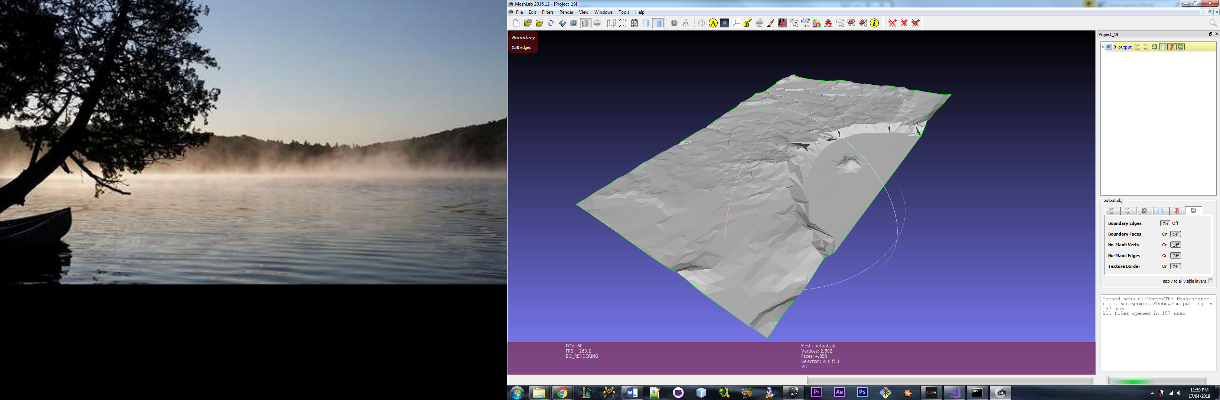

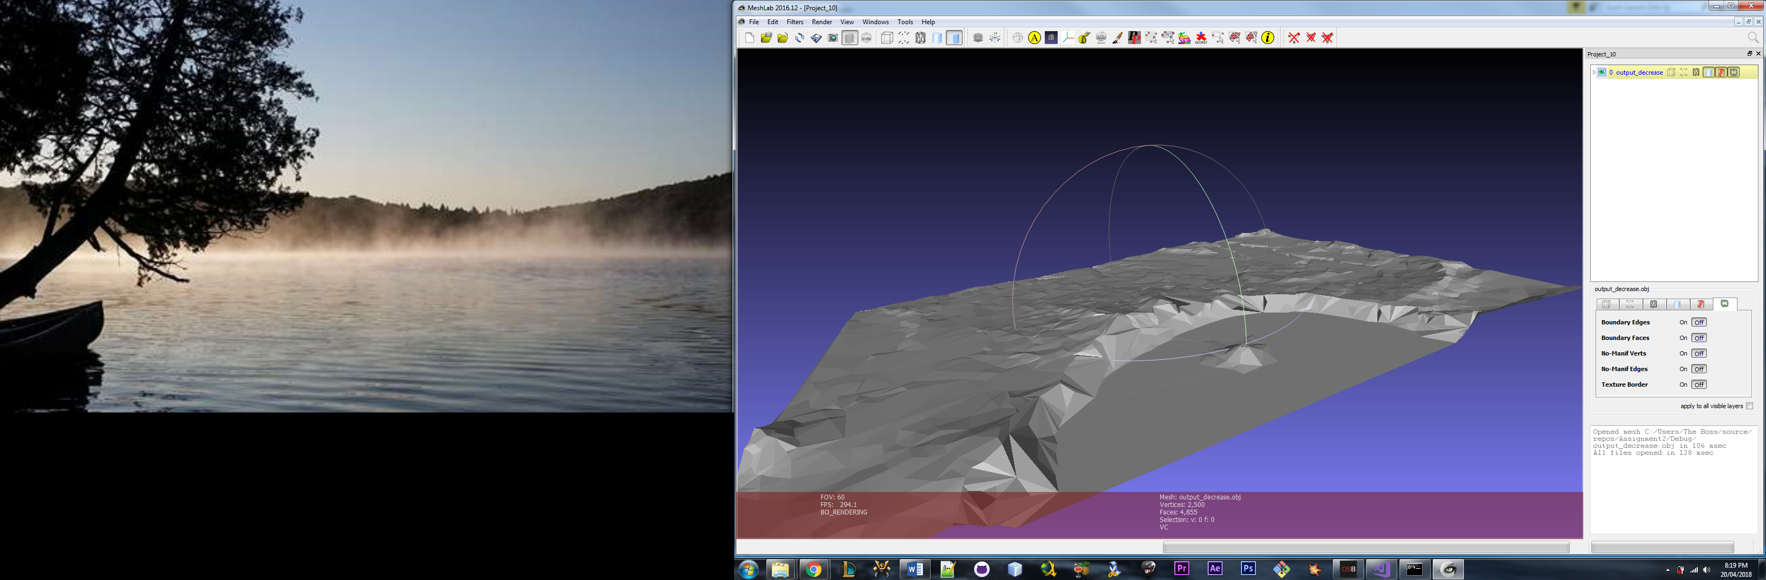

**Figure 6.** 50% mesh reduction 1 step, 2500 vertices removed

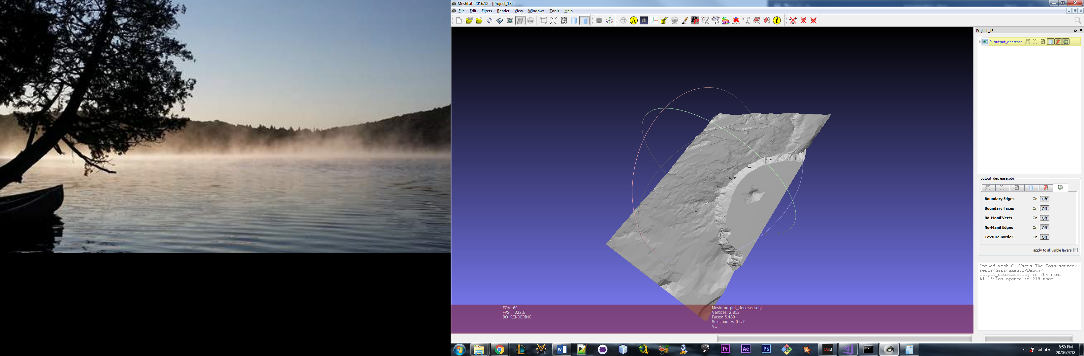

**Figure 7.** 50% reduction in 2 steps (25% reduction, then 33% reduction from that), 1250 vertices removed then 937

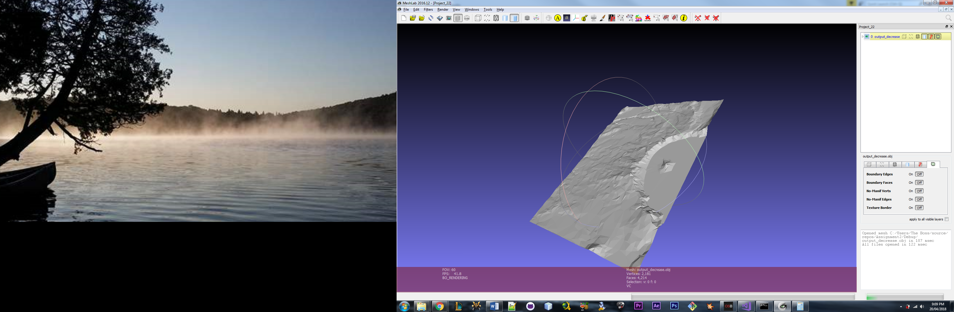

**Figure 8.** 50% reduction in 5 steps

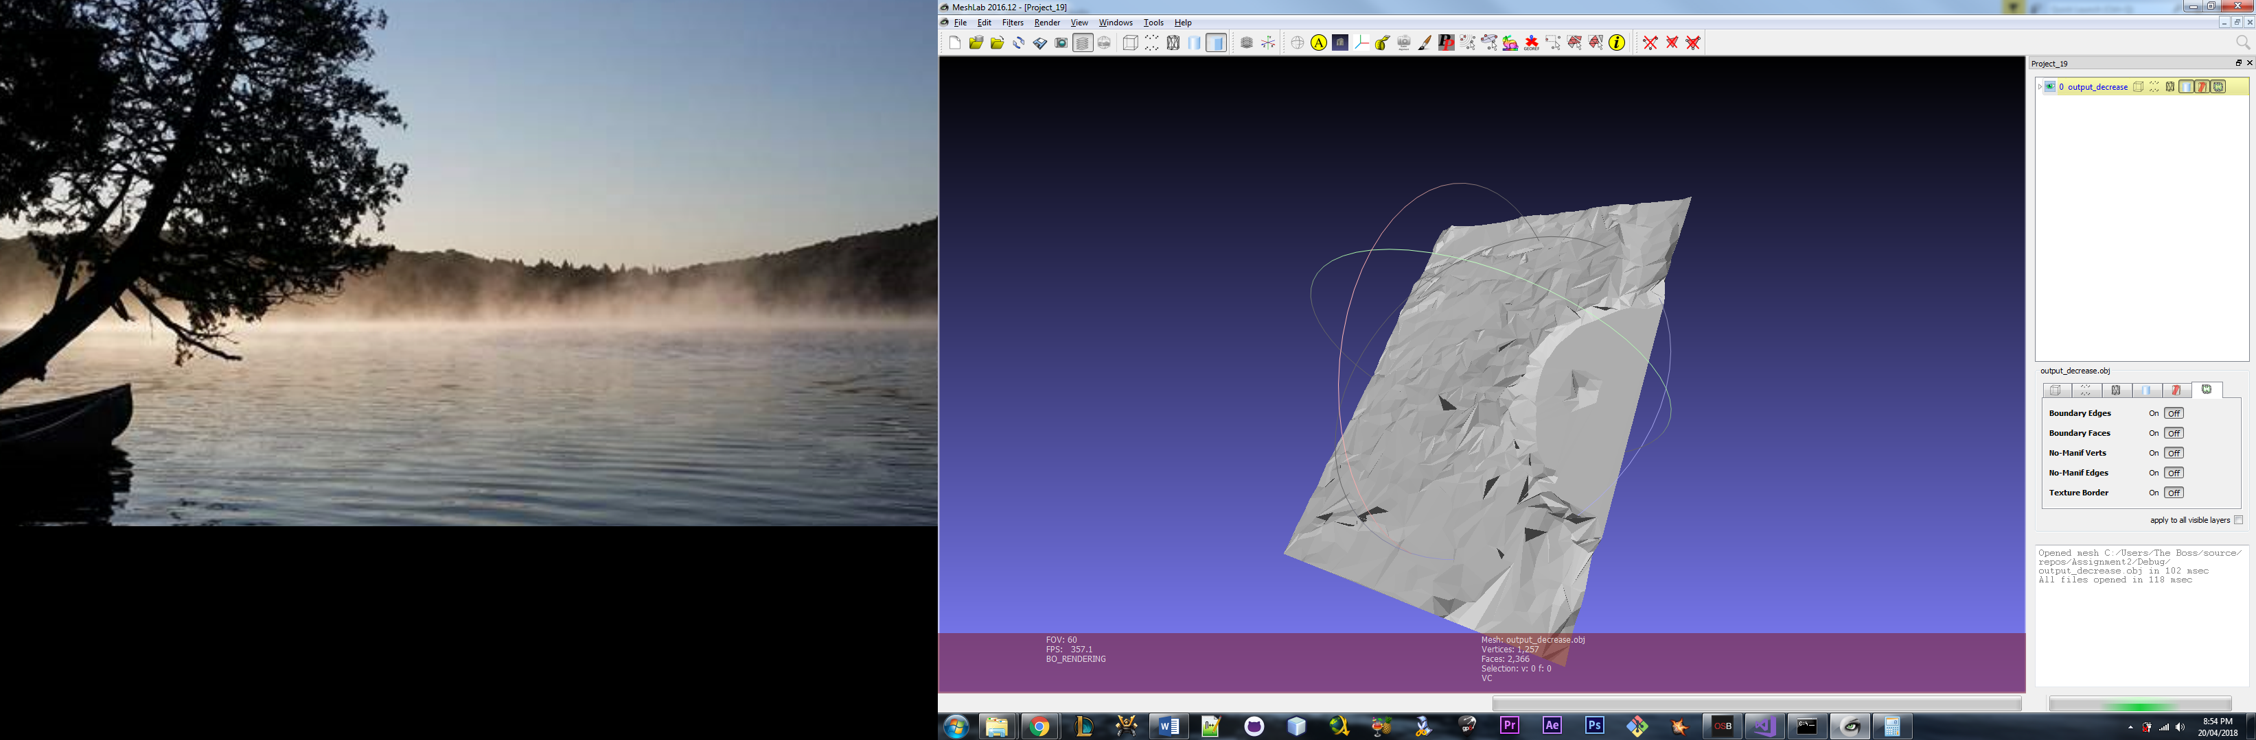

**Figure 9.** 75% reduction in 3 steps (25% reduction, then 33% reduction from that, then 50% reduction from that), 1250 vertices removed then 937

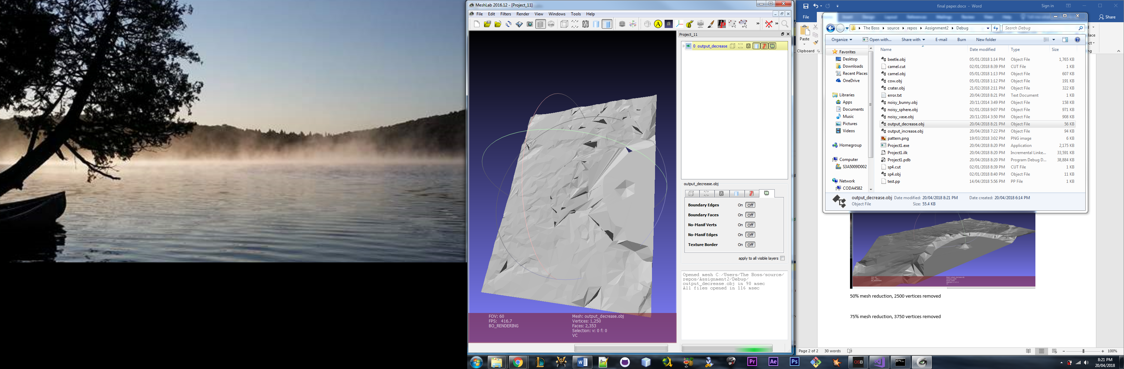

**Figure 10.** 75% mesh reduction 1 step, 3750 vertices removed

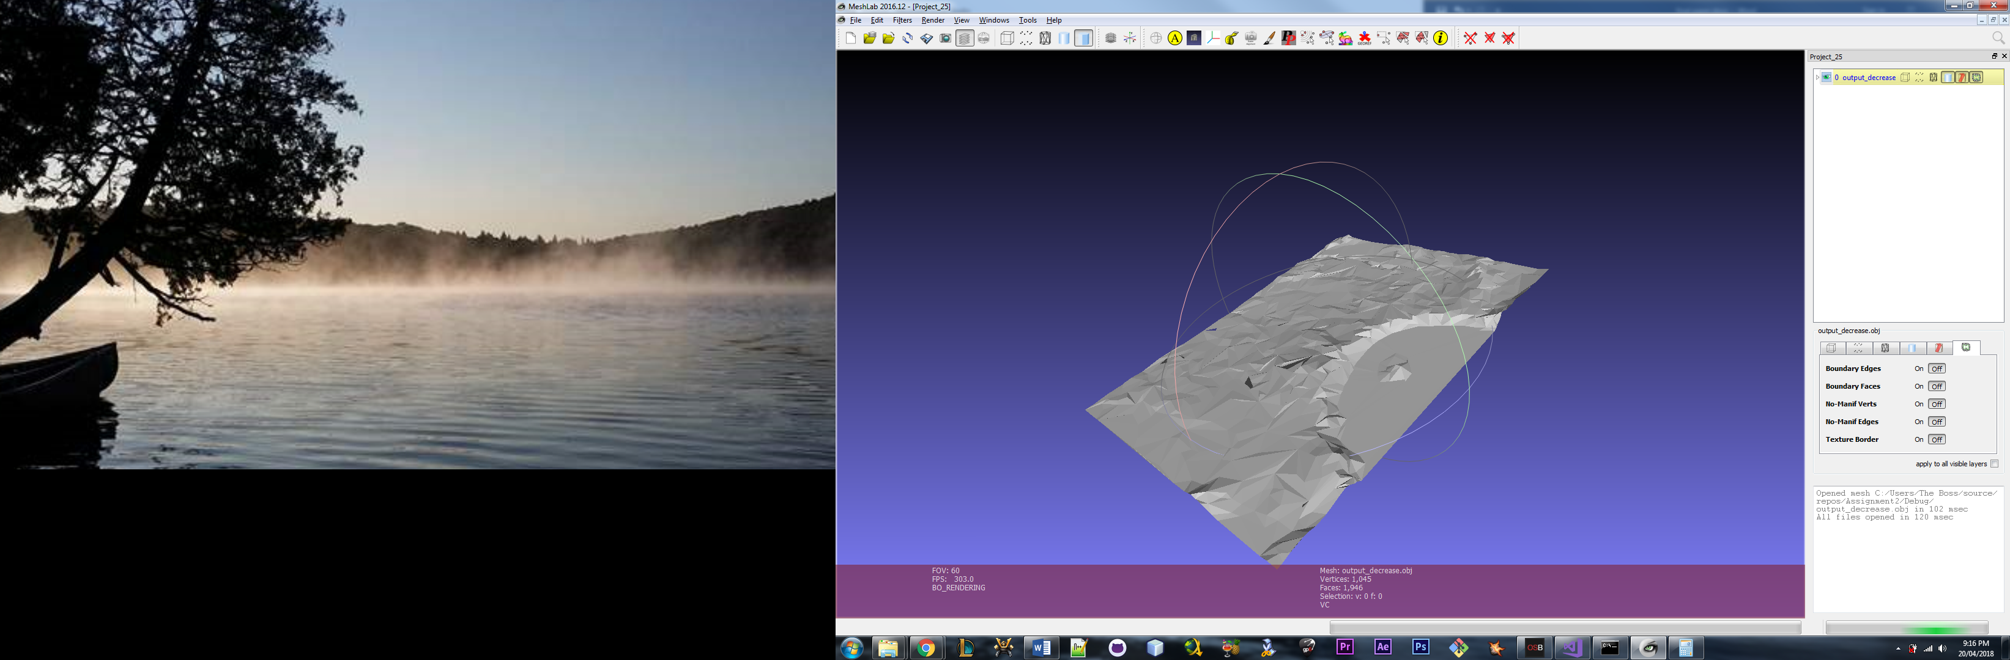

**Figure 11.** 79% reduction in 6 steps

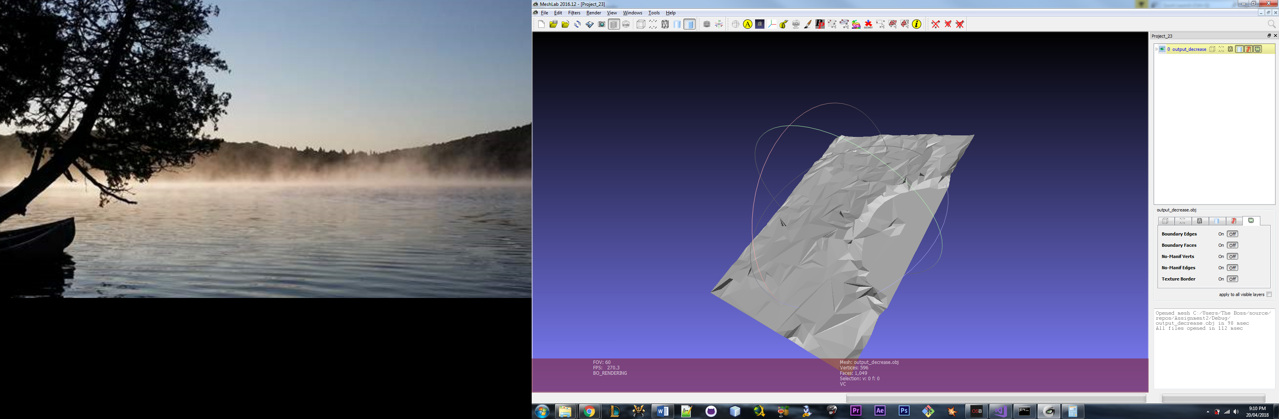

**Figure 12.** 88% in 8 steps

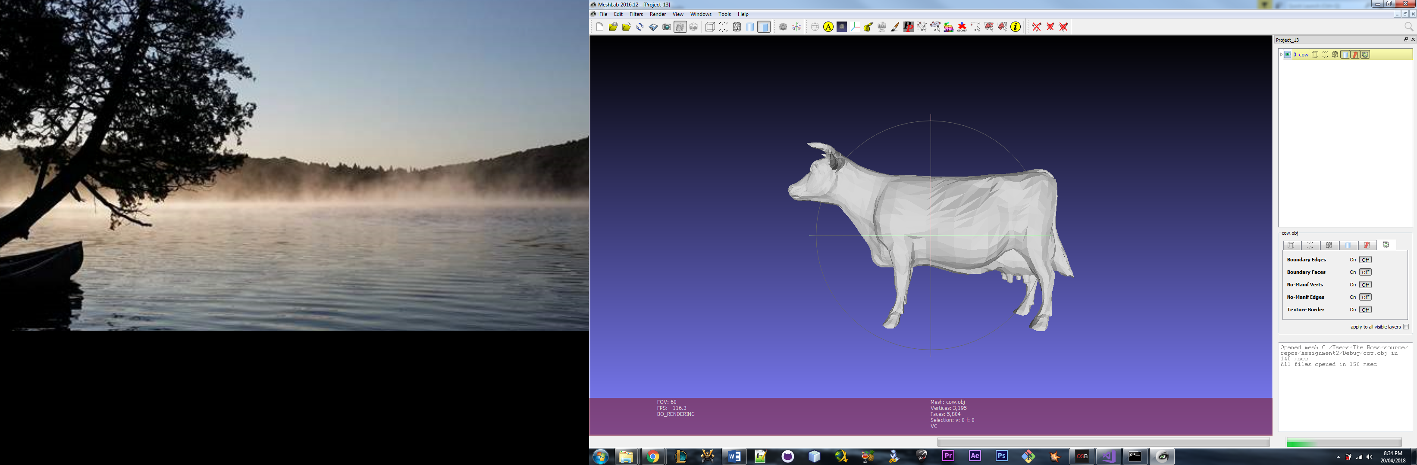

**Figure 13.** Original cow mesh

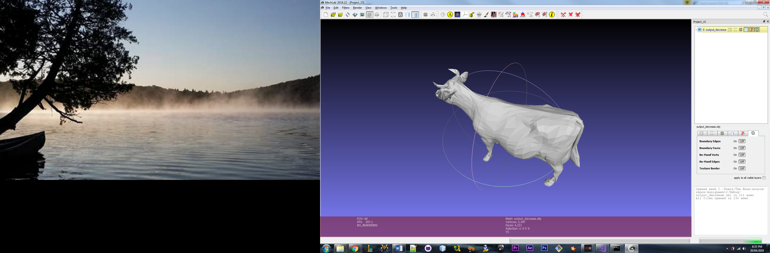

**Figure 14.** 25% reduction 1 step, 798 vertices removed

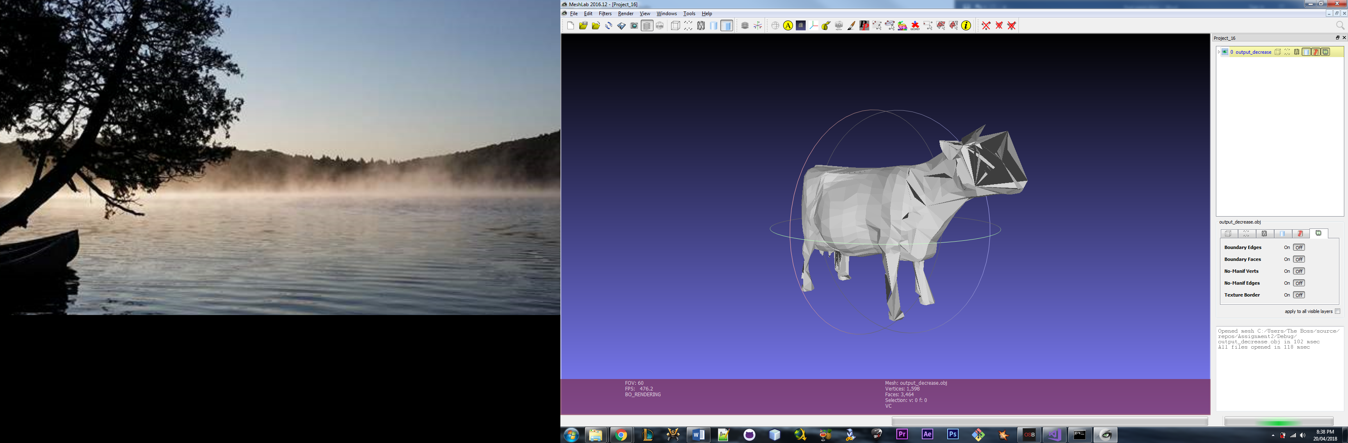

**Figure 15.** 50% reduction 1 step, 1597 vertices removed. There are clearly some problems here.

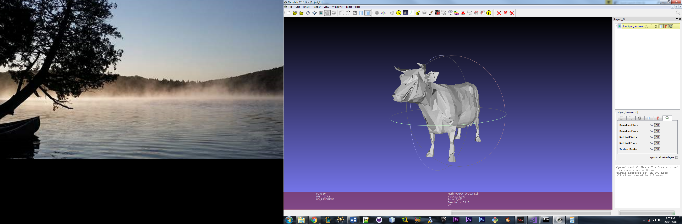

**Figure 16.** 50% reduction in 2 steps

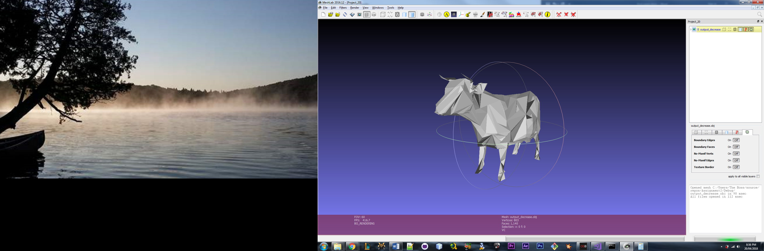

**Figure 17.** 75% reduction in 3 steps

## References

[1] OpenMesh. https://www.openmesh.org/

[2] Image from course notes on Mesh Simplification

http://people.scs.carleton.ca/~olivervankaick/courses/geomproc/Winter2018/Topic%206%20-%20Mesh%20simplification.pdf